Upload Image To IBM Container

|  |  |
| --- | --- |
| **Date** | 11 November 2022 |
| **Team ID** | PNT2022TMID02701 |
| **Project Name** | Smart Fashion Recommender Application |

CREATING REPOSITORY IN IBM CLOUD:

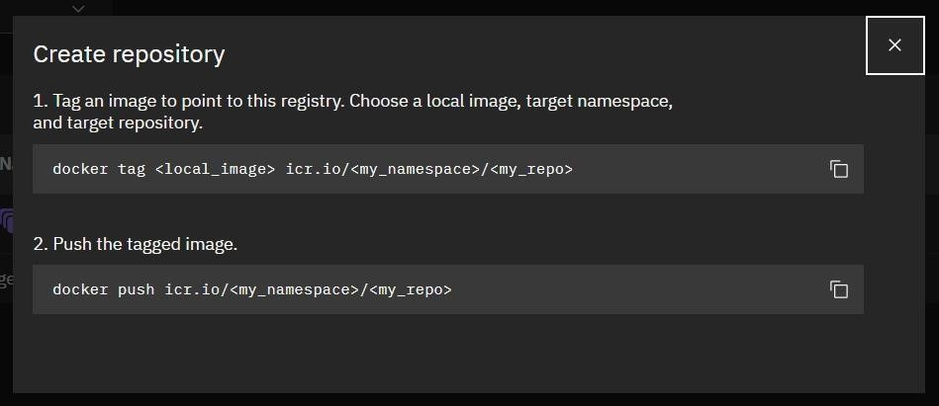

UPLOAD IMAGE TO IBM CONTAINER REGISTRY:

